Topics in Software Engineering I

Assignment # 01Style Guidelines for Final Year Project Reports

A 4th Year StudentSubmitted to: DR. Fatima Sabir

A project submitted in partial fulfilment of the

COMSATS University Degree of

BSc. (Hons.)BS in Computer Science / Software Engineering (CUI)



Department of Computer Science

COMSATS University Islamabad, Lahore Campus

**05 October 2022**

**Project Registration**

|  |  |  |  |  |  |  |  |
| --- | --- | --- | --- | --- | --- | --- | --- |
| Project ID (for office use) | | |  | | | | |
| Type (Nature of project) | | | [ ] **D**evelopment [ ] **R**esearch [ **•** ] **R**&**D** | | | | |
| Area of specialization | | |  | | | | |
| **Project Group Members** | | | | | | | |
| Sr.# | Reg. # | Student Name | | CGPA | Email ID | Phone # | Signature |
| (i) | SP20-BSE-061 | M Mateen Saleem | | 3.0 | SP20-BSE-061@cuilahore.edu.pk |  |  |
| (ii) | SP20-BSE-108 | Syed Arslan Ali Shah | | 3.0 | SP20-BSE-108@cuilahore.edu.pk |  |  |
| (iii) | SP20-BSE-037 | Shameer Khalid | | 3.0 | SP20-BSE-0037@cuilahore.edu.pk |  |  |
| (iv) | SP19-BSE-092 | Syed Haris | | 3.0 | SP19-BSE-092@cuilahore.edu.pk |  |  |
| Name & Signature of Batch Advisor  (If students are eligible for FYP) | | | |  | | | |

1. **Explore your project and find all options discussed in lecture 2 from Chapter 2. You need to prepare a google doc that highlights the potential issue that your code has. You may identify these issues with the help of**
2. **Identify deprecated technology or APIs. Just report the diagram.**

**Solution: -**

Java and xml technology is used in this project for the development of mobile application. But if we look according to today’s technology we can use react native and flutter for mobile app development. React components wrap existing native code and interact with native APIs using the declarative UI paradigms of React and JavaScript. This enables native app development for entirely new development teams, and significantly speeds up work for existing native teams. On the other hand if we talked about Flutter includes a rendering engine, pre-made widgets, testing and integration APIs, etc. because it is a complete SDK. Let's discuss the key parts and the general operation of the system. Flutter's three primary structural tiers are

**Platform-specific embedder**: that makes the application run on any OS;

**C/C++ engine:** that offers a low-level implementation of Flutter's main APIs. This comprises a framework built on the Dart programming language, graphics (via the Sika 2D graphics library), text layout, file and network I/O, accessibility support, plugin architecture, a Dart runtime, and a compilation toolchain.

**Framework:** Although its implementation is optional, it offers a comprehensive collection of libraries that may be broken down into four layers: the material/Cupertino library, the rendering layer, the widget layer, and the fundamental foundational classes.

**Diagram:**

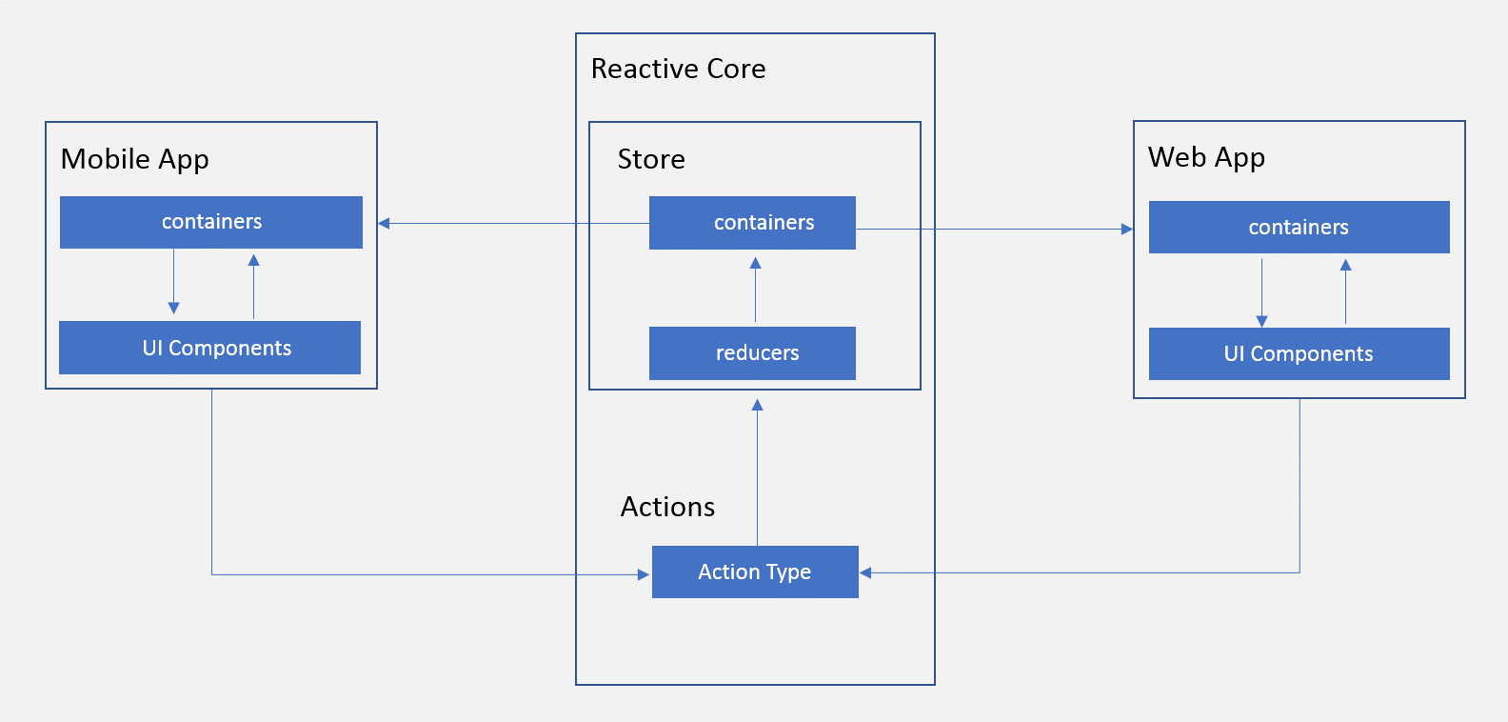

1. **Potential issues missing in the documentation but available in the code**

**Solution:**

Potential issues of the code will be find out after running and compiling the code.

1. **missing of technical documentation ( if applicable )**

* Documentation is outdated
* Don’t have User Manual

1. **Use PMD to help identify potential coding errors and customize the rules you use to make sure only pertinent rules are applied to your source code.**
2. Create & view code issues directly from your editor
3. Track & prioritize code improvements like technical debt
4. Check your code quality
5. Apply at least 3 PMD rules with the help of tool
6. Generate the Abstract Syntax Tree of your source code using PMD.

**Code Issues Using PMD:**

1. **Rule Filed Name Conventions**

Field Naming Convention Issue: The Constant name

***__ID_item_price //LINE 33***

1. **Commenting**

Field comments are required in line 32 to enhance Readability.

private final static ***int __ID_category_id = PendingOrderProjectBox_.category_id.id; //LINE 32***

1. **Rule Local Variable**

Local variable ‘name’ declared as final

String name = entity.getName();// LINE 53

**Fixing Code Issues Created By PMD:**

1. **Rule Filed Name Conventions**

Field Naming Convention issue can be solved by using following naming convention

private final static int ID_ITEM_PRICE=PendingOrderProjectBox_.item_price.id;//LINE 31

1. **Commenting**

Name of developer should be placed as commenting that the code has been changed by the person i.e. person name in multi-line commenting or single line commenting.

/*

Dev Name

<Changes>

*/

1. **Rule Local Variable**

This can be solved if Name will not be assigned again in the string method as final

**Abstract Syntax Tree of Source Code**

Abstract Syntax tree of source code is attached.

**c) Use the Check Style tool to review your code. At least apply 2 rules on your code using Check Style**

**Code Issues Using CheckStyle**

* ‘member def.’ modifier has incorrect indentation

private final static int ***__ID_category_id*** = PendingOrderProjectBox_.***category_id***.id; //LINE 33

* static modifier out of order with the JLS suggestions

private final static int __ID_item_price = PendingOrderProjectBox_.item_price.id; //LINE 32

**The above can be solved by adding static before private and final.**

Static private final int ***__ID_item_price*** = PendingOrderProjectBox_.***item_price***.id;

**PMD and Check Style Method:**

